

**American International University- Bangladesh**

**CSC 3215: Web Technologies**

**CO2 and CO4 Evaluation**

**Finished Project Report**

**Spring 2019-2020**

**Project Title: Photo Artistry**

**Section: B**

|  |  |
| --- | --- |
| Student Name | Student Id |
| Nuzhut Tabassum | **19-39967-1** |
| Anindita Roy | **19-40001-1** |
| Nazia Tabassum | **17-34479-2** |
| Md. Muhaiminul Islam | **19-39968-1** |

**Project Description:**

*Describe your project in short and its main functionalities. You can create sub-heading under this heading with your own formatting. (No more than 300 words)*

**Project Folder Structure:**

*Provide your project folder structure clearly here.*

**Core Modules of the Project:**

*Here, add THREE of your CORE modules’ source code with appropriate filename as heading. (Use either* consolas or courier new *font for source code)*

*For example:*

***login.php***

*/* Your Source code for this module */*

***shop.php***

*/* Your Source code for this module */*

***checkout.php***

*/* Your Source code for this module */*

**Database Schema:**

|  |  |  |  |  |  |
| --- | --- | --- | --- | --- | --- |
| **CO2 and CO4 Evaluation: Project Report Evaluation** | | | | | |
| **Completeness**  **(5)** | **Validation**  **(5)** | **Feature Implementation**  **(5)** | **Concept Understanding**  **(5)** | **Promptness (5)** | **Total (25)** |
|  |  |  |  |  |  |
|  | | | | | |

**Project Description:**

**Photo Artistry** is our photography website. On our website there is a photo gallery. On this gallery many categories of photo here. For example, Adventure photography, Weeding photography, Film photography, Fashion photography and so on. Every consumer can see this gallery. Besides there has a portion named photographers where has many categories of photo as like the gallery. Here users may choose any photo and if user click on this photo the website will take the user to that photographer profile who upload this photo on our website. Consumers may hire this photographer through our website.  There are four types of users can use our website. They are photographers, customers, tutors and learners. Photographers can create their own profile. And they can upload many kinds of images. Besides on that photographer account they can get notify whose customers are hired them.

Customers can search event packages and they can give ratings for the photographer. They can request a booking for their events. Customers can contact the photographers. Our website provides photography course in many categories. Such as Weeding, Adventure, Film, Event, Nature and so on. Who will enroll this courses they have to create an account in our website as a learner. Learner can register and they can enroll in the courses. They can also contact the tutors and they pay for their enrolled courses. They can give ratings for their course tutors.

Our website has many qualified tutors. If any of them think they are expert on, photography they can apply as a tutor in our website. For applying, they have to create a account in our website as tutor. They can see how many students they have and also they can see who want to learn photography under them.

Overall, our website not only for hire photographer. Our website also provides expert tutor on photography. Who actually passionate on photography and want to learn then welcome to our website. Not only, we also hire expert tutor. Who are really good at photography, they can also apply as a tutor in our website.

**Project Folder Structure:**

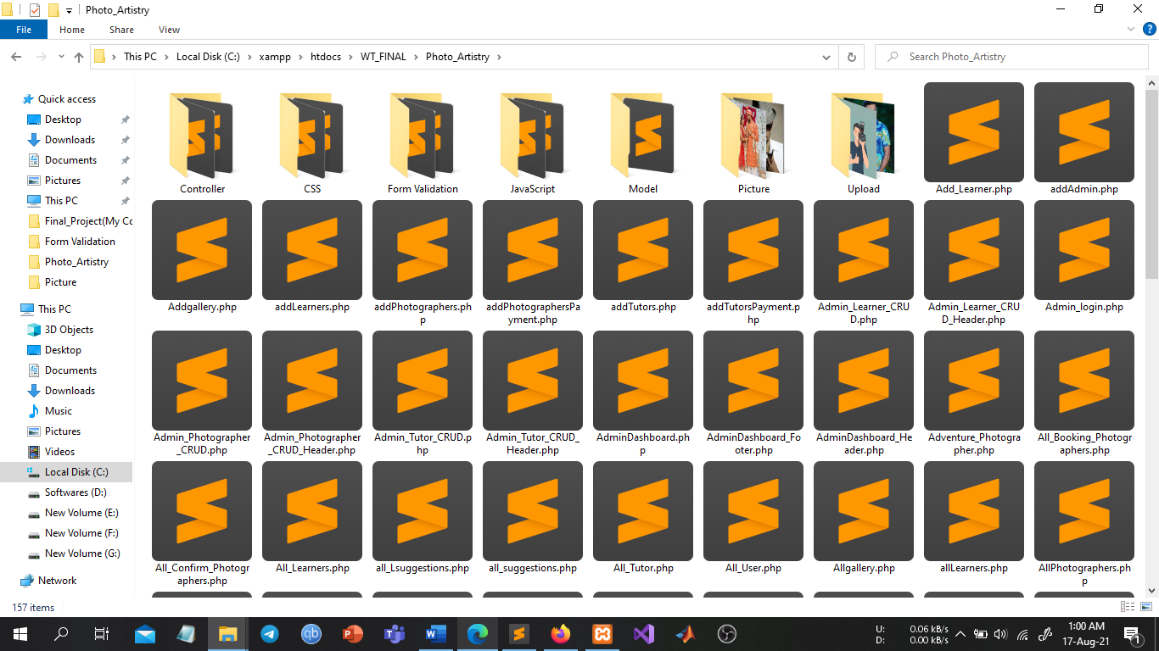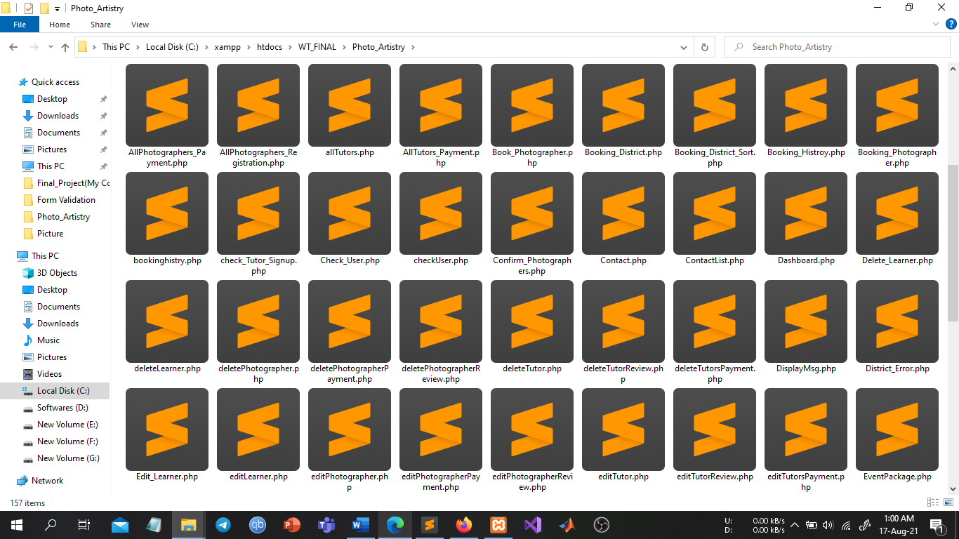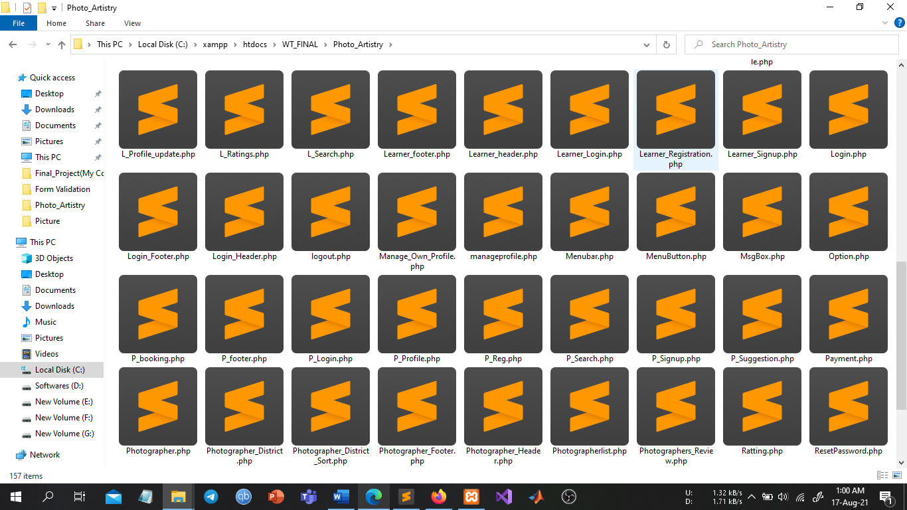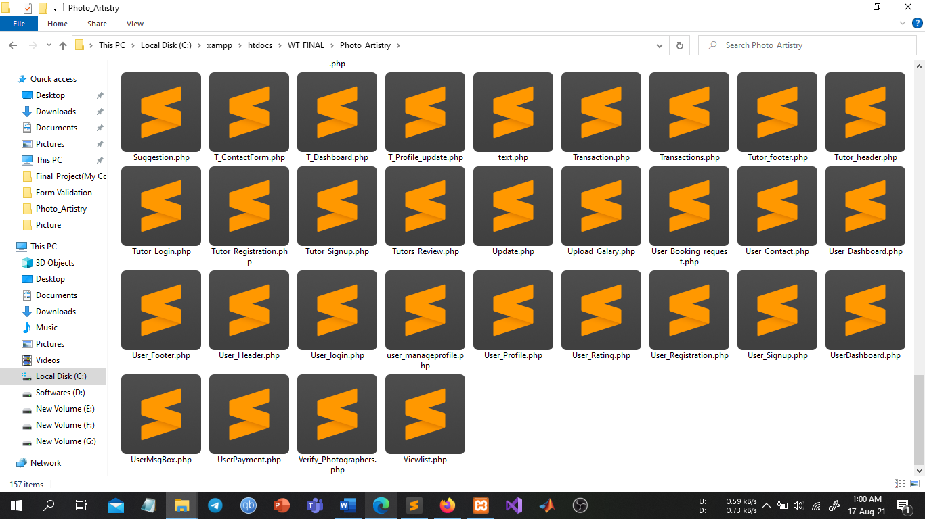

**Core Modules of the Project:**

**Start.php**

<?php

include 'Start_Header.php';

include 'Option.php';

?>

<section id="banner">

<img src="Picture/logo2.png" class="logo">

<div class="container">

<span class="text1">Welcome to</span>

<span class="text2">PhotoArtistry</span>

</div>

</section>

<?php

include 'Menubar.php';

include 'MenuButton.php';

?>

<section id="gallary">

<div class="title">

<h2>Photo Gallary</h2>

</div>

</section>

<div id="img">

<h1 align="left">&nbsp;Wedding Photography:</h1><br>

&nbsp;&nbsp;&nbsp;&nbsp;&nbsp;&nbsp;&nbsp;&nbsp;

<?php

echo "<img src='Picture/1.jpg' height='400' width='400' vspace='20' class='img1'>&nbsp;&nbsp;&nbsp;&nbsp;&nbsp;&nbsp;";

?>

<img src="Picture/43.jpg" height="400" width="400" vspace="20" class="img1">&nbsp;&nbsp;&nbsp;&nbsp;&nbsp;&nbsp;

<img src="Picture/57.jpg" height="400" width="400" vspace="20" class="img1"><br>&nbsp;&nbsp;&nbsp;&nbsp;&nbsp;&nbsp;&nbsp;&nbsp;&nbsp;&nbsp;&nbsp;<br>&nbsp;&nbsp;&nbsp;&nbsp;&nbsp;&nbsp;&nbsp;&nbsp;&nbsp;&nbsp;&nbsp;

<?php

foreach ($wedding as $w)

{

echo "<img src='".$w["img"]."' height='400' width='400' vspace='20' class='img1'>&nbsp;&nbsp;&nbsp;&nbsp;&nbsp;&nbsp;";

}

?>

<br><br><br>

<h1 align="left">&nbsp;Adventure Photography:</h1><br>

&nbsp;&nbsp;&nbsp;&nbsp;&nbsp;

<img src="Picture/5.jpg" height="400" width="400" vspace="20" class="img1">&nbsp;&nbsp;&nbsp;&nbsp;&nbsp;&nbsp;&nbsp;&nbsp;

<img src="Picture/6.jpg" height="400" width="400" vspace="20" class="img1">&nbsp;&nbsp;&nbsp;&nbsp;&nbsp;&nbsp;&nbsp;&nbsp;

<img src="Picture/7.jpg" height="400" width="400" vspace="20" class="img1"><br>&nbsp;&nbsp;&nbsp;&nbsp;&nbsp;&nbsp;&nbsp;&nbsp;&nbsp;&nbsp;&nbsp;<br>&nbsp;&nbsp;&nbsp;&nbsp;&nbsp;&nbsp;&nbsp;&nbsp;&nbsp;&nbsp;&nbsp;

<?php

foreach ($adventure as $a)

{

echo "<img src='".$a["img"]."' height='400' width='400' vspace='20' class='img1'>&nbsp;&nbsp;&nbsp;&nbsp;&nbsp;&nbsp;";

}

?>

<br><br><br>

<h1 align="left">&nbsp;Event Photography:</h1><br>

&nbsp;&nbsp;&nbsp;&nbsp;&nbsp;

<img src="Picture/76.jpg" height="400" width="400" vspace="20" class="img1">&nbsp;&nbsp;&nbsp;&nbsp;&nbsp;&nbsp;&nbsp;&nbsp;

<img src="Picture/9.jpg" height="400" width="400" vspace="20" class="img1">&nbsp;&nbsp;&nbsp;&nbsp;&nbsp;&nbsp;&nbsp;&nbsp;

<img src="Picture/10.jpg" height="400" width="400" vspace="20" class="img1"><br>&nbsp;&nbsp;&nbsp;&nbsp;&nbsp;&nbsp;&nbsp;&nbsp;&nbsp;&nbsp;&nbsp;<br>&nbsp;&nbsp;&nbsp;&nbsp;&nbsp;&nbsp;&nbsp;&nbsp;&nbsp;&nbsp;&nbsp;

<?php

foreach ($event as $e)

{

echo "<img src='".$e["img"]."' height='400' width='400' vspace='20' class='img1'>&nbsp;&nbsp;&nbsp;&nbsp;&nbsp;&nbsp;";

}

?>

<br><br><br>

<h1 align="left">&nbsp;Film Photography:</h1><br>

&nbsp;&nbsp;&nbsp;&nbsp;&nbsp;

<img src="Picture/11.jpg" height="400" width="400" vspace="20" class="img1">&nbsp;&nbsp;&nbsp;&nbsp;&nbsp;&nbsp;&nbsp;&nbsp;

<img src="Picture/12.jpg" height="400" width="400" vspace="20" class="img1">&nbsp;&nbsp;&nbsp;&nbsp;&nbsp;&nbsp;&nbsp;&nbsp;

<img src="Picture/13.jpg" height="400" width="400" vspace="20" class="img1"><br>&nbsp;&nbsp;&nbsp;&nbsp;&nbsp;&nbsp;&nbsp;&nbsp;&nbsp;&nbsp;&nbsp;<br>&nbsp;&nbsp;&nbsp;&nbsp;&nbsp;&nbsp;&nbsp;&nbsp;&nbsp;&nbsp;&nbsp;

<?php

foreach ($film as $f)

{

echo "<img src='".$f["img"]."' height='400' width='400' vspace='20' class='img1'>&nbsp;&nbsp;&nbsp;&nbsp;&nbsp;&nbsp;";

}

?>

<br><br><br>

<h1 align="left">&nbsp;Fashion Photography:</h1><br>

&nbsp;&nbsp;&nbsp;&nbsp;&nbsp;

<img src="Picture/14.jpg" height="400" width="400" vspace="20" class="img1">&nbsp;&nbsp;&nbsp;&nbsp;&nbsp;&nbsp;&nbsp;&nbsp;

<img src="Picture/15.jpg" height="400" width="400" vspace="20" class="img1">&nbsp;&nbsp;&nbsp;&nbsp;&nbsp;&nbsp;&nbsp;&nbsp;

<img src="Picture/16.jpg" height="400" width="400" vspace="20" class="img1"><br>&nbsp;&nbsp;&nbsp;&nbsp;&nbsp;&nbsp;&nbsp;&nbsp;&nbsp;&nbsp;&nbsp;<br>&nbsp;&nbsp;&nbsp;&nbsp;&nbsp;&nbsp;&nbsp;&nbsp;&nbsp;&nbsp;&nbsp;

<?php

foreach ($fashion as $fa)

{

echo "<img src='".$fa["img"]."' height='400' width='400' vspace='20' class='img1'>&nbsp;&nbsp;&nbsp;&nbsp;&nbsp;&nbsp;";

}

?>

<a href="#" class="to-top">

<i class="fas fa-arrow-up"></i>

</a>

</div>

<?php

include 'Footer.php';

include 'Start_Footer.php';

?>

**Photographer.php**

<?php

include 'Photographer_Header.php';

?>

<div class="back">

<font face="Comic sans MS" size="4" class="option2">

<a href="Start.php">Home</a>&nbsp;&nbsp;&nbsp;&nbsp;&nbsp;&nbsp;

<a href="#" target="blank">About Us</a>&nbsp;&nbsp;&nbsp;&nbsp;&nbsp;&nbsp;

<a href="#">Contact US</a>&nbsp;&nbsp;&nbsp;&nbsp;&nbsp;&nbsp;

</font>

</div>

<section id="banner2">

<img src="Picture/logo2.png" class="logo">

<h2 data-text="We are Providing Our Best Photographers For You">We are Providing Our Best Photographers For You</h2>

</section>

<?php

include 'Menubar.php';

include 'MenuButton.php';

?>

<div id="img">

<a href="#" class="to-top">

<i class="fas fa-arrow-up"></i>

</a>

<h2>Photographers</h2><br><br>

<h1 align="left">&nbsp;Wedding Photographer:</h1><br>

&nbsp;&nbsp;&nbsp;&nbsp;&nbsp;&nbsp;&nbsp;&nbsp;

<a href="#"><img src="Picture/1.jpg" class="img1"></a>&nbsp;&nbsp;&nbsp;&nbsp;&nbsp;&nbsp;

<a href="#"><img src="Picture/43.jpg" class="img1"></a>&nbsp;&nbsp;&nbsp;&nbsp;&nbsp;&nbsp;

<a href="#"><img src="Picture/57.jpg" class="img1"></a>

<br><br><br>

<h1 align="left">&nbsp;Adventure Photographer:</h1><br>

&nbsp;&nbsp;&nbsp;&nbsp;&nbsp;

<a href="#"><img src="Picture/5.jpg" class="img1"></a>&nbsp;&nbsp;&nbsp;&nbsp;&nbsp;&nbsp;&nbsp;&nbsp;

<a href="#"><img src="Picture/6.jpg" class="img1"></a>&nbsp;&nbsp;&nbsp;&nbsp;&nbsp;&nbsp;&nbsp;&nbsp;

<a href="#"><img src="Picture/7.jpg" class="img1"></a>

<br><br><br>

<h1 align="left">&nbsp;Event Photographer:</h1><br>

&nbsp;&nbsp;&nbsp;&nbsp;&nbsp;

<a href="#"><img src="Picture/76.jpg" class="img1"></a>&nbsp;&nbsp;&nbsp;&nbsp;&nbsp;&nbsp;&nbsp;&nbsp;

<a href="#"><img src="Picture/9.jpg" class="img1"></a>&nbsp;&nbsp;&nbsp;&nbsp;&nbsp;&nbsp;&nbsp;&nbsp;

<a href="#"><img src="Picture/10.jpg" class="img1"></a>

<br><br><br>

<h1 align="left">&nbsp;Film Photographer:</h1><br>

&nbsp;&nbsp;&nbsp;&nbsp;&nbsp;

<a href="#"><img src="Picture/11.jpg" class="img1"></a>&nbsp;&nbsp;&nbsp;&nbsp;&nbsp;&nbsp;&nbsp;&nbsp;

<a href="#"><img src="Picture/12.jpg" class="img1"></a>&nbsp;&nbsp;&nbsp;&nbsp;&nbsp;&nbsp;&nbsp;&nbsp;

<a href="#"><img src="Picture/13.jpg" class="img1"></a>

<br><br><br>

<h1 align="left">&nbsp;Fashion Photographer:</h1><br>

&nbsp;&nbsp;&nbsp;&nbsp;&nbsp;

<a href="#"><img src="Picture/14.jpg" class="img1"></a>&nbsp;&nbsp;&nbsp;&nbsp;&nbsp;&nbsp;&nbsp;&nbsp;

<a href="#"><img src="Picture/15.jpg" class="img1"></a>&nbsp;&nbsp;&nbsp;&nbsp;&nbsp;&nbsp;&nbsp;&nbsp;

<a href="#"><img src="Picture/16.jpg" class="img1"></a>

<div class="overlay"></div>

</div>

<?php

include 'Footer.php';

include 'Photographer_Footer.php';

**?>**

**Login.php**

<?php

include 'Login_Header.php';

include 'Option.php';

?>

<section id="banner">

<img src="Picture/logo2.png" class="logo">

</section>

<?php

include 'Menubar.php';

include 'MenuButton.php';

?>

<br><br><br><br><br><br><br><br><br>

<h1 align="center">

<font face="Comic sans MS" size="7" color="#cc6600">Login As<br>

<a href="#"><button>Photographer</button></a>&nbsp;&nbsp;&nbsp;

<a href="#"><button>Customer</button></a>&nbsp;&nbsp;&nbsp;

<a href="#"><button>Tutor</button></a>&nbsp;&nbsp;&nbsp;

<a href="#"><button>Learner</button></a>&nbsp;&nbsp;&nbsp;

<a href="Admin_login.php"><button>Admin</button></a>

</font>

</h1>

<br><br><br>

<h1 align="center">

<font face="Comic sans MS" size="7" color="blue">Sign-Up As<br>

<a href="#"><button>Photographer</button></a>&nbsp;&nbsp;&nbsp;

<a href="#"><button>Customer</button></a>&nbsp;&nbsp;&nbsp;

<a href="#"><button>Tutor</button></a>&nbsp;&nbsp;&nbsp;

<a href="#"><button>Learner</button></a>&nbsp;&nbsp;&nbsp;

</font>

</h1>

<?php

//include 'Footer.php';

include 'Login_Footer.php';

?>

**About_Us.php**

<!DOCTYPE html>

<html>

<head>

<meta charset="utf-8">

<title>About Us</title>

</head>

<body background="20.png" link="#000" alink="#017bf5" vlink="#000">

<img src="logo2.png" height="150" width="160" align="left">

<br><br>

&nbsp;&nbsp;&nbsp;&nbsp;&nbsp;&nbsp;&nbsp;&nbsp;&nbsp;&nbsp;&nbsp;&nbsp;&nbsp;&nbsp;&nbsp;&nbsp;&nbsp;&nbsp;&nbsp;&nbsp;&nbsp;&nbsp;&nbsp;&nbsp;&nbsp;&nbsp;&nbsp;&nbsp;&nbsp;&nbsp;&nbsp;&nbsp;&nbsp;&nbsp;&nbsp;&nbsp;&nbsp;&nbsp;&nbsp;&nbsp;&nbsp;

<font face="Comic sans MS" size="4">

<a href="Page.php">Home</a>&nbsp;&nbsp;&nbsp;&nbsp;&nbsp;&nbsp;

<a href="upload.php" target="blank"target="blank"target="blank">Upload</a>&nbsp;&nbsp;&nbsp;&nbsp;&nbsp;&nbsp;

<a href="Photographer_Hire.php" target="blank">Photographers</a>&nbsp;&nbsp;&nbsp;&nbsp;&nbsp;&nbsp;

<a href="Course.php" target="blank">Course</a>&nbsp;&nbsp;&nbsp;&nbsp;&nbsp;&nbsp;

<a href="Contact.php" target="blank">Contact US</a>&nbsp;&nbsp;&nbsp;&nbsp;&nbsp;&nbsp;

<a href="Rating.php" target="blank">Rating</a>&nbsp;&nbsp;&nbsp;&nbsp;&nbsp;&nbsp;

<a href="Feedback.php" target="blank">Feedback</a>&nbsp;&nbsp;&nbsp;&nbsp;&nbsp;&nbsp;

<a href="Login.php" target="blank">Login</a>

</font>

<br><br><br><br><br><br><br><br><br>

<h1 align="center">

<font size="8" color="#ff0000" face="Impact" >About Us</font>

</h1>

<br><br><br>

<font size="5" face="Times New Roman" color="blue">

Photo Artistry provides high quality photos and all of the photos are nicely tagged, searchable . It also offer Photography courses to the people by which one can turn their passion for photography into a reality. By completing this course one can Develop their individual style and gain key business skills for a successful career. Also photography contest are organized here . That competitive edge is a really good way of driving one’s photography on by that extra few percent. It also gives the people direction and pushes them out of their comfort zone.We help millions of designers, writers, artists, programmers and other creators to get access to beautiful photos that they can use freely which empowers them to create amazing products, designs, stories, websites, apps, art and other work.

</font>

</body>

</html>

**Contact.php**

<!DOCTYPE html>

<html>

<head>

<meta charset="utf-8">

<title>Contact Us</title>

</head>

<body background="72.jpg" link="#000" alink="#017bf5" vlink="#000">

<img src="logo2.png" height="150" width="160" align="left">

<br><br>

&nbsp;&nbsp;&nbsp;&nbsp;&nbsp;&nbsp;&nbsp;&nbsp;&nbsp;&nbsp;&nbsp;&nbsp;&nbsp;&nbsp;&nbsp;&nbsp;&nbsp;&nbsp;&nbsp;&nbsp;&nbsp;&nbsp;&nbsp;&nbsp;&nbsp;&nbsp;&nbsp;&nbsp;&nbsp;&nbsp;&nbsp;&nbsp;&nbsp;&nbsp;&nbsp;&nbsp;&nbsp;&nbsp;&nbsp;&nbsp;&nbsp;

<font face="Comic sans MS" size="4">

<a href="Page.php">Home</a>&nbsp;&nbsp;&nbsp;&nbsp;&nbsp;&nbsp;

<a href="About_Us.php" target="blank">About Us</a>&nbsp;&nbsp;&nbsp;&nbsp;&nbsp;&nbsp;

<a href="upload.php" >Upload</a>&nbsp;&nbsp;&nbsp;&nbsp;&nbsp;&nbsp;

<a href="Photographer_Hire.php" target="blank">Photographers</a>&nbsp;&nbsp;&nbsp;&nbsp;&nbsp;&nbsp;

<a href="Course.php" >Course</a>&nbsp;&nbsp;&nbsp;&nbsp;&nbsp;&nbsp;

<a href="Rating.php" target="blank">Rating</a>&nbsp;&nbsp;&nbsp;&nbsp;&nbsp;&nbsp;

<a href="Feedback.php" target="blank">Feedback</a>&nbsp;&nbsp;&nbsp;&nbsp;&nbsp;&nbsp;

<a href="Login.php">Login</a>

</font>

<br><br><br><br><br>

<h1 align="center">

<font face="Comic sans MS" size="7" color="#cc6600">

Contact With Us Via<br><br>

<a href="https://www.facebook.com/muhaiminul.shahed" target="blank"><img src="73.png" height="150" width="250"></a>&nbsp;&nbsp;&nbsp;

<a href="https://t.me/DeadGhost007" target="blank"><img src="73.webp" height="130" width="150"></a>&nbsp;&nbsp;&nbsp;&nbsp;

<a href="http://instagram.com/nuzhuttabassum" target="blank"><img src="74.webp" height="130" width="150"></a>&nbsp;&nbsp;&nbsp;&nbsp;

<a href="https://m.me/muhaiminul.shahed" target="blank"><img src="74.png" height="130" width="150"></a>

</font>

</h1>

</body>

</html>

**Database Schema:**

